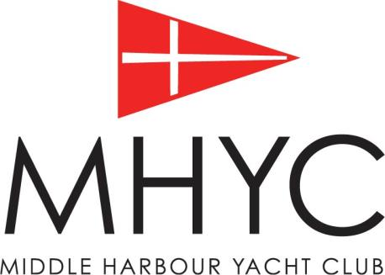
2018 Winter Education Program

Topic | Presenter | Group | Venue | Date
Volunteer Information Session  Free Presentation | David Staley & Phil Clinton | Potential and existing volunteers | MHYC | Wed 27th June at 7pm
First Aid Marine Focus – Surf Life Saving NSW  (over 2 nights) 6.00-9.30pm $115 pp | SLSNSW | Owners, Skippers, Crew, RM Volunteers, Instructors, Coaches | MHYC | Wed 11th & 18 July at 6pm
Powerboat Handling  https://flyingfishsailing.com.au/events/81-nsw-boat-licence/  10% discount applies to MHYC Members | Flying Fish | Owners, Skippers, Crew, RM Volunteers, Instructors, Coaches | MHYC | Sat 14th July or Sat 11th August
Race Management, Flags and Signals  Free Presentation | David Staley | Owners, Skippers, Crew, RM Volunteers | MHYC | Wed 1st August at 6.30pm
VHF Radio Operator’s Course ( SROCP) -  ( over 2 nights )  Member price $220 pp 6.30-9.00pm | Flying Fish | Owners, Skippers, Crew, RM Volunteers, Instructors, Coaches | MHYC | Wed 8th and 15th August at 6.30pm
Boat Preparation and Maintenance – Hull & Rigging  Free Presentation | TBC | Owners, Skippers, Crew | MHYC | Proposed Wed 22nd August at 6.30pm TBC
Club Judge Seminar  www.yachtingaustralia.com.au/event.asp?ID=84723 | Australian Sailing | Owners, Skippers, Crew, Volunteers | MH16’ Skiff | Sat 25th August – all day
On-board Emergencies – Are You prepared?  MOB, Dismasting, Fire etc - Free Presentation | Flying Fish | Owners, Skippers, Crew Coordinators | MHYC | Wed 5th Sept

Topic | Presenter | Group | Venue | Date
Equipment Auditor Training www.sailing.org.au/upcoming-equipment-auditor-courses | Australian Sailing | Prospective Club Auditors | RPAYC | Sat 8th September
Sail Selection and Use  Free Presentation | Billy Sykes  & Michael Coxon  North Sails | Owners, Skippers, Crew | MHYC | Wed Sept 12th at 6.30pm
Racing Tactics – Starts, Upwind, Downwind, Mark Roundings, Finishes  Free Presentation | TBC | Owners, Skippers, Crew | MHYC | TBC
Skippers Briefing  Formal compulsory session outlining the 2018-2019 Sailing Program including a presentation by RMS and Sydney Ports | Kerry Burke, David Staley, RMS & Sydney Ports | Owners, Skippers | MHYC | Thurs 20th Sept at 7pm
Crew Meet & Greet | Deb, MySail | Owners, Skippers, Crew Coordinators | MHYC | Thurs 27th Sept at 6.30pm
Racing Rules, Protest and Request for redress  Free Presentation (6pm on a Wed TBC) | TBC | Owners, Skippers, Crew, RM Volunteers | MHYC | Proposed Wed 3 or 10th Oct at 6.30pm TBC
Essential Navigation and Seamanship Online Course  https://flyingfishsailing.com.au/events/85-essential-navigation-and-seamanship-online/  $225 plus 10% discount for MHCY Members | Flying Fish Online Course | Owners, Skippers, Crew | Online | Self-Paced  Learning
AS/ISAF Offshore Safety and Sea Survival  https://flyingfishsailing.com.au/events/80-as-isaf-offshore-safety-and-sea-survival/  $595 plus 10% discount for MHYC Members | Flying Fish | Owners, Skippers, Crew | MHYC | Sat 13th & 14th Oct
RYA Diesel Engines  Overall awareness of the main systems of a marine diesel engine.  https://flyingfishsailing.com.au/events/43-rya-diesel-engines/  $350 plus 10% discount for MHYC Members | Flying Fish | Owners, Skippers, Crew | MHYC | 28th Nov
On-board Emergencies – Practical Session  Cost-Tbc | Flying Fish | Owners, Skippers | MHYC On Water | Tbc

Further Information
Catherine Rofe
MHYC Sailing Administrator
Tel: 8969 3103
Email: sailing@mhyc.com.au

