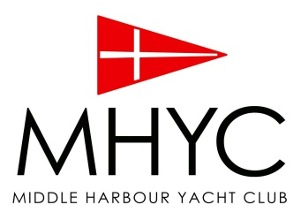
OPTIMIST NSW CHAMPIONSHIPS
LUNCH ORDERS

Please return to MHYC office or email sailing@mhyc.com.au before 11am on Thursday 3rd December.
Lunches will be available from the SandBar Café from approximately 10am.

Full Name:
Phone (mobile):
Cost per lunch order $12.00 per day
Select one of: | Saturday  Qty | Sunday  Qty
Vietnamese Rice Paper Rolls x 2 Peking Duck
Vietnamese Rice Paper Rolls x 2 Vegetarian
Sushi ‘Maki’ Hand Rolls x 2 Teryaki Chicken
Sushi ‘Maki’ Hand Rolls x 2 Cooked Tuna
Chicken Ceasar Sandwich
Ham, Cheese & Tomato Sandwich
Veggie, Feta & Pesto Sandwich
All lunches include:
Small Packet of Chips
Juice Popper
Allen’s Killer Python

*Please note any special requests for GF or other food allergies here:
__________________________________________________________________________
__________________________________________________________________________

Credit Card details for pre-payment: Visa Mastercard AMEX
Card no: __ __ __ __ __ __ __ __ __ __ __ __ __ __ __ __
Exp Date: ____ / ____
Name on Card: __________________________________________
Total to be charged: $____________

