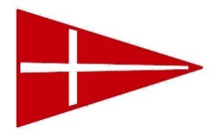
FARR 40 LUNCH ORDERS

Please return to MHYC office 48 hours before the event
Boat name: __________________________________
Ordered by: ___________________________________
Phone (mob): __________________________
Need to be collected by (approx time): ___________

Email to sailing@mhyc.com.au no later than Thursday 16 January

Description | Price per item | Qty for Saturday | Qty for  Sunday | Total $
Ham & Salad Roll | $8.50
Chicken Wrap | $10.00
Falafel & salad wrap | $10.00
Rare Roast Beef & Salad Roll | $9.50
Crumbed Chicken Schnitzel & salad Roll | $9.50
Turkey, Cranberry Sauce & Salad roll | $9.00
Spicy Salami & Salad roll | $10.50
Kettle Chips (varied flavours) 150g size | $6.00
Bag of Ice | $5.00
Mt Franklin 600ml water | $15/6 bottles  $25/12 bottles
Assorted soft drink cans | $12/6 cans  $20/12 cans
TAKEAWAY BEER & WINE AVAILABLE FROM CAFE
*Please note any special requests for GF or other food allergies.
CC details for pre-payment: Visa Mastercard AMEX
Card no: __ __ __ __ __ __ __ __ __ __ __ __ __ __ __ __
Exp Date: __ / __
Name on card: __________________________________________
Total to be charged: $____________

